CAWT CONNECT COACHING NETWORK

Governance Arrangements

Version 10 (June 2012)

Contents
1. Governance of the Connect Coaching Service 3
1.1 Purpose
1.2 Ethos

2. What does the CONNECT Coaching Network offer? 4
2.1 What is coaching?
2.2 Vision of the CAWT CONNECT Coaching Network
2.3 CAWT Context

3. How does the CONNECT Coaching Network operate? 6
3.1 Leadership development need
3.2 Is Coaching the most effective support?
3.3 Alternative Support
3.4 Referral to CONNECT Coaching Network
3.5 Eligibility
3.6 Matching with a Coach
3.7 introductory Conversation
3.8 Continue with the coach?
3.9 Coaching Agreement
3.10 Coaching Activity
3.11 Continuing with Coaching
3.12 Final Review of Coaching
3.13 Coaching Closure
3.14 Achievement of goals

4. Key Roles and Responsibilities 14
4.1 Line Manager
4.2 Coachees
4.3 Coaches
4.4 Coach Mentors
4.5 Supervision
4.6 Connect Coaching Network Coordination (HR)
4.7 Contact

5. Monitoring and Evaluation 17
6. Complaints 18
7. Integration of coaches with other credentials 18
Templates
Appendix One: Code of Ethics
1. Governance of the Connect Coaching Service

  - Purpose
The CAWT partners are establishing a unique internal coaching service designed to increase leadership capability to support organisational transformation. Establishing and operating an internal coach service across four partner organisations is an ambitious goal. The Service will be provided in partnership across the Western Health and Social Care Trust, the Health Service Executive – West, the Southern Health and Social Care Trust and the Health Service Executive – Dublin North East.
The purpose of the governance arrangements is to ensure the smooth running of the CAWT Connect Coaching Network. These will dovetail with the governance arrangements for the mentoring service. The governance arrangements are outlined in the following sections:
- What does the Connect Coaching Network offer?
- How does the Connect Coaching Network operate?
- Who does what? Key roles and responsibilities.
- How is it monitored and evaluated?
- What if ....handling complaints?

The supporting documentation and templates are also included.

1.2 Underpinning Ethos
The underpinning philosophy of the coaching service is the belief in individual potential – in an individual’s ability to use their creativity and intelligence to solve any problems and challenges they face and to achieve their goals. The Connect Coaching Service is based on three guiding principles which best practice elsewhere has highlighted as critical for success:

- Coaching is an integral component of the overall learning and development strategy of the partner organisations and is seen as a valuable opportunity
- Trust by the organisation in the coaches and coachees to link the coaching with wider organisational strategies and goals
- Empowerment of coaches and coachees to use their judgment with minimal interference recognising that confidentiality and safety is necessary to enable meaningful learning and personal development
2. What does the CONNECT Coaching Network offer?

2.1 What is Coaching?

There are many forms of development and support for professional practitioners/specialists/service managers or clinical leaders. Coaching is one specific approach. The International Coach Federation defines coaching as

‘Partnering with clients in a thought-provoking and creative process that inspires them to maximize their personal and professional potential.’

Another ICF description highlights what is distinctive about coaching:

- the client chooses the focus of the discussion,
- the coach listens and contributes observations and questions.
- the interaction creates clarity and moves the client into action.
- the client’s progress is accelerated by providing greater focus and awareness of choice
- the concentration is on where the client is now and what they are willing to do to get where they want to be in the future

The results from the coaching are determined by the client’s intentions, choices and actions, which are supported by the coach’s efforts and application of the coaching process.

The CAWT Connect Coaching Network offers a 1:1 time-limited coaching service offered by internal, trained coaches to managers, clinicians and staff.

2.2 Vision of the CAWT CONNECT Coaching Network

The CAWT CONNECT Coaching Network is an innovative and strategic approach to building capacity and performance in the four CAWT partner organisations and community/voluntary stakeholders. Over seventy coaches will be equipped with the skills, competences and understanding to support service leaders to transform service provision across the CAWT partner organisations.

Health and Social Care delivery organisations in the Health Service Executive in the South and the Health and Social Services Trusts and Boards in the North have been significantly restructured during the last five years. The current economic pressures in both jurisdictions mean that managers must continue to find new ways of delivering quality services across all settings in the face of increasing demands in all areas.

All research and literature on organisational change and process improvement highlights the importance of the “human factor”. Organisations don’t change – people do. This requires leadership which can inspire staff, is credible and delivers results. The coaching service will support and challenge leaders to be effective in leading change and transformation.
The CAWT geographical area has 20% population of the whole population on the island. This project has the potential to have a demonstrable impact on the health and social care systems in the north and south of Ireland

2.3 CAWT Context

The CONNECT Coaching service will be provided by internal coaches who have undergone training recognised by the International Coach Federation (ICF). 72 Connect coaches will support their individual ‘coachees’ who are leaders and managers in the CAWT partner organisations to lead change and service improvement initiatives.

Each CONNECT coach fulfils this role in addition to his/her designated job role in the HSC/HSE. The CAWT partners are collaborating and sponsoring this service across the four organisations.

The Connect Coaching Network is unique because it will provide:
- fresh perspectives through the cross-over of coaches into another CAWT organisation
- exchange of knowledge, information, skills, ideas and services for the benefit of service users in the CAWT area
- fostering of trust, cooperation and sharing as a basis for successful service delivery across disciplines, services, organisations and jurisdictions
- supported by a web based portal for accessing the coaching service
- a coach mentoring network

3. How does the CONNECT Coaching Network operate?

This section will outline how the CONNECT Coaching Network operates. The first step in the coaching pathway is when an individual leader decides that they would benefit from coaching as they undertake some challenge in their role. The coaching pathway is completed when the contracted coaching goals are achieved. The coaching pathway is represented in the flow chart on page 8.

The steps in the coaching pathway are described in detail below.

3.1 Leadership Challenge

The Coaching Service is to be provided for any professional practitioner/specialist/service manager or clinical leader in the CAWT partner organisations who is engaged in transforming and improving their service area. There are inevitable challenges in taking change forward. Individuals may feel they would benefit from 1:1 coaching relationship in planning and expediting their service improvement goals.

Coaching may be effective where managers/leaders/professionals are:
- Taking forward service improvements or development initiatives,
- Developing new working practices, roles and responsibilities as a result of organisational change
- Newly appointed to their role
- Seeking to develop their skills as part of personal/professional development
- Being developed for future succession

3.2 Is Coaching the most effective support?

The individual should explore if coaching is the most effective option with their line manager/ sponsor/ and/or the HR learning and development leads in their organisation. Coaching is one of a range of arrangements which may be available.

Coaching may be an effective solution if the individual is motivated and where one-to-one support over a limited period of time would be valuable. Ideally, the referral to coaching should be supported by their line manager.

3.3 Alternative Support

Other available alternatives may be more suitable and should be explored by the individual and their line manager:
- Skills and knowledge training, e.g. in service improvement techniques, project management
- In-house training and development programmes
- E-learning
- Mentoring where advice and guidance is provided by someone more experienced.
- Line Manager advice and support
- Professional supervision
- Employee Relations
- Occupational Health

Other supports may be developed in the future and added to this list of options.
Coaching Pathway Templates
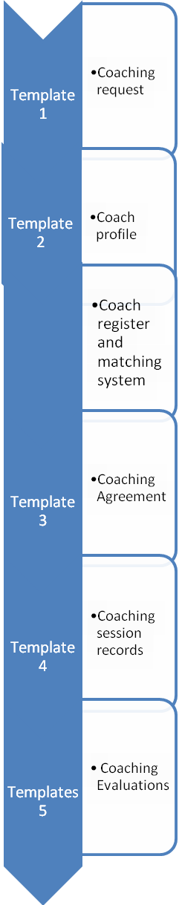
14. Individual Goals Achieved
13. Closure
No
Yes
1. Individual faces challenge in leadership role
4. Request for CONNECT Coaching
5. Eligible?
8. Continue
3. Alternative support
2. Coaching?
6. Match with Coach
10. Coaching Activity
11. Review
7. Introductory Conversation
9. Coaching Contract
Yes
Yes
Yes
No
No
12. Continue?

No
3.4 Referral to CONNECT Coaching Network

Individual or their line manager completes the online referral to CONNECT Coaching Network (see Template 1: Coaching Request). The information required includes:
- Demographic information, role, location and hours of work
- Reason for coaching request
- What the applicant is looking for in a coach
- Support from line manager and their expectations of outcome from coaching

The referral will be responded to within five working days.

3.5 Eligibility

To be eligible to use the CONNECT Coaching Service, individuals must be employed within one of the CAWT partner organisations, must supported by their organisation and meet one or more of the following criteria:
- In a clinical or service leadership/management/project lead role or be a specialist practitioner
- Leading service improvement/development
- Facing a work based challenge,
- Be newly appointed to their role

3.6 Matching with a Coach

The individual will be matched with a coach who preferably works in one of the other three CAWT partner organisations but at times a coach from the individual’s own organisation may be chosen. The individual can access coach profiles online (Template 2: Coach Profile). Matching will depend on issues such as:
- Coach availability and capacity, which is regulated by the individual coach, monitored by the HR coordinators to ensure balance and equity and ensure that coaches fulfil their designated hours
- Coach requirements as specified by the coachee or their line manager
- Avoidance of conflicts of interest
Please note: Selection of a coach should be based on the coach’s experience and potential for objectivity, rather than if they are from a similar discipline or organisational level.

The individual will choose from available coaches only. The individual confirms which coach they will approach. The individual can then initiate contact with their first choice coach to set up the ‘Introductory Conversation’.

3.7 Introductory Conversation

The coach and coachee’s first exchange is an introductory conversation. This will typically take place by telephone unless it is convenient to meet.

The purpose is for the coach to:
- Describe their philosophy and approach as a coach
- Define coaching and how it is different from other development methods
- Agree how the coaching process will work, e.g. number of sessions, whether by phone or face to face meetings, location, time of day, duration, recording of sessions
- Begin co-designing the coaching alliance by finding out what is important to the coachee and coach in terms of building an effective working relationship
- Agree confidentiality, ethics, feedback
- Ensure compatibility and discuss alternatives if necessary
- Share information on qualifications, background and supervision

3.8 Commence coaching?

In the event that either the coachee or the coach thinks that the match will not form a sufficiently good coaching partnership, the decision not to proceed should be recorded online. Potential reasons may include
- Inappropriate use of coaching
- Conflict of interest
- Mismatch of client needs and coach approach.
- Other

Tracking these reasons will help the Connect Coaching service refine the matching process over time. The coachee may choose a second coach from the available panel. Alternatively the individual may choose to pursue an alternative development method.

A copy of the Coaching Agreement (Template 3) is sent to the coachee (and their line manager is if appropriate) by the coach for discussion.

3.9 Coach Agreement

The coaching agreement between the coach and the coachee is the basis of good practice, setting out goals, roles, arrangements and timeframes. It is the reference point in the coaching partnership enabling the coach and coachee to check they are on track. A simple written agreement will be recorded between the coach and coachee covering:
- Goals and expectations
- Method, timing, duration and frequency of coaching sessions
- Ground rules e.g. confidentiality, feedback to line manager
- Ending Agreement: either party having the freedom to terminate the arrangement and inform each other
- Commitment to appointments: if there are two consecutive missed appointments the coaching relationship can be ended by the other party.
The Coaching Agreement can be completed during the Introductory Conversation if it seems that that coaching is likely to proceed, or it may be following the introductory conversation if the coachee would like some time to think it through. The coach can be the judge of this.

It is recommended that the coaching agreement is completed before the first coaching session.

In the organisational setting, the coach and coachee need to be mindful of the organisational interests. Generally, these are represented by the line manager, who can promote coaching as an effective developmental method. .

There will be situations where the coachee sees it important for the line manager to participate in making the coaching agreement. In these instances a tri-partite meeting or conversation may be facilitated by the coach. The agenda may follow the suggested structure below:

- Clarify the line manager’s and coachee’s expectations of coaching, the outcomes they hope to achieve and success criteria.
- Agree confidentiality, feedback processes (by the coachee in regard to the coaching process, and by the line manager in regard to positive outcomes they have noticed), review and evaluation processes, and documentation.
- Confirm practical arrangements, i.e. number of sessions, timeframe, duration of sessions, cover for the coachee during sessions, prioritisation, handling cancellations and line manager’s assistance to enable participation.
- The three parties complete the Coaching Agreement, all sign and each gets a copy (see Template 3: Coaching Agreement).

3.10 Coaching Activity

The coaching activity proceeds as agreed – ideally via telephone unless it is geographically close. Use of technology, e.g. Skype, should be encouraged in consultation with the support of the ICT service.

Sessions may last from 30 minutes to one hour. Sessions may be fortnightly, monthly or bi-monthly.
Any travel/subsistence claims must be agreed in advance by the relevant line managers, i.e. the coachee’s line manager and the coach’s line manager.

The timing of sessions may be ‘out of hours’ if the busyness of the working day is not conducive to effective participation by either the coach or coachee. Time off in lieu for coaching sessions outside of normal working hour must be approved by line manager .There will be no additional accrual of pay or benefits for work undertaken outside of normal working hours.
The coach maintains a short record of the coaching sessions and agrees the content with the coachee (see Template 4: Coaching Session Record).

3.11 Continuing with Coaching

If after 4 sessions it is concluded that further coaching would be beneficial, the Coaching Agreement is updated and the plan for the next sessions agreed.

A coachee may have their coaching extended, if this is agreed as necessary and beneficial by the coach, coachee and the line manager. The Coaching Contract will be updated to reflect revised goals and time frames.

3.12 Final Review of Coaching

When the coaching process is ended, a review discussion is facilitated by the coach. This should take place (by phone or in person), ideally within two weeks of the last coaching session and no later than four weeks. This covers the following questions:
- How far have the agreed goals been achieved?
- How effective has the coaching process been?
- What are the next steps?
This may involve the coachee’s line manager/sponsor if they were involved in the initial tri partite coaching agreement.
3.13 Coaching Evaluation

An evaluation of the coaching is completed by the coachee and their sponsor online(Template 5a): Coaching Evaluation - Coachee and Template 5b) Coaching Evaluation - Sponsor ). .. These are monitored by the CONNECT Coaching Co-ordinator

This enables the evaluation of the coaching service as well as providing developmental feedback and quality assurance for the coaches.
The evaluations are shared with the individual coach and may be used to inform their supervision. Individual coach evaluations are kept confidential and no one is identified in any coaching evaluation reports that are prepared for the Connect Coaching Steering Group.

The coach will ensure that all coaching session information is collated and sent to the Coaching Co-ordinator for secure storage.

3.14 Achievement of goals

As a result of the coaching, it is expected that the coachee will experience a number of benefits, which are likely to include:
- Progress with expediting their leadership challenge or service improvement project
- Increased confidence and self-belief
- Increased self-awareness
- Increased thinking and analysis skills
- Able to use a goal-centred problem solving approach with own team and colleagues in the workplace
- Improved relationships with others
- Increased awareness of the benefits of coaching
4. Key Roles and Responsibilities

This section will describe the key roles and responsibilities in the CONNECT Coaching Network.

The development of the CONNECT Coaching Network will take place during 2011-2012, with the external support of Coaching Development and managed through the CAWT Mobility Project.

At the end of the set up phase of the CONNECT Coaching Network, the Coaching Service will be co-ordinated across the CAWT partner organisations through the learning and development teams. The service will use an online system for processing referrals, matching coaches and storage of coaching generated information for future evaluation.

The support and supervision of the coaches will be provided internally.

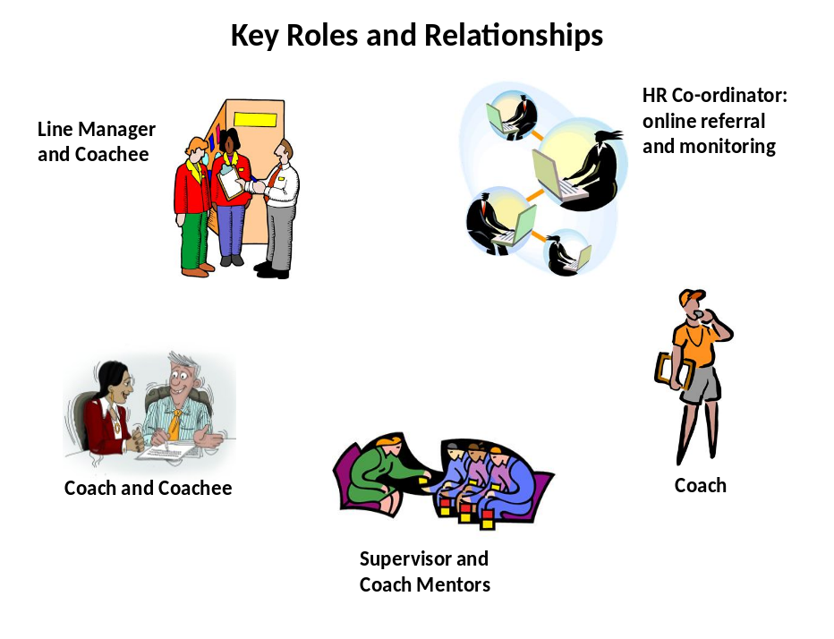

A short description of roles and responsibilities is summarised below.

4.1 Line Manager/Sponsor

- Promotes the use of coaching for staff development
- May suggest or initiate a coaching referral for a staff member.
- Provides feedback to the coachee on the impact and outcomes achieved through the coaching, as the line manager has perceived it.
- Provides evaluation on the impact and benefits of the coaching engagement.

4.2 Coachee

- Uses coaching to support their leadership development and change management learning
- Fulfils agreements made at the contracting stage
- Informs the coach promptly if postponement / cancellation is necessary
- Engages in the coaching work, is prepared and follows through on actions from sessions
- Evaluates the coaching service and benefits

4.3 Coach

- Will have achieved the Coaching Essentials Award, or equivalent, which is ICF approved as providing the required minimum level of professional training for coaches.
- Complies with Professional Code of Ethics (Appendix One)
- Has support of own line manager to provide ‘job plus’ coaching
- Is able to offer 4-8 hours coaching per month. It is strongly recommended that coaches accrue a minimum of 30 hours per year to keep coaching proficiency levels.
- Participates in regular supervision / coach mentoring sessions and two network meetings per annum
- Supports the policies, practices and objectives of the Coaching Service
- Maintains agreed confidential records of coaching sessions for purposes of evaluation and quality assurance

4.4 Coach Mentor

- Will have been supported through 4 additional training days to fulfil additional requirements (receiving ‘coach mentoring’ from Coaching Development staff, accumulating client hours and passing ICF examination) to achieve their individual ICF credential as an Associate Certified Coach (ACC)
- Provides support to Connect coaches and encourages their reflective practice and continuing development of coaching skills.
- Arranges continuing professional development events and network meetings
- Ensures standards of coaching practice comply with ICF standards and code of professional ethics
- Each coach mentor will support a maximum of 2-3 coaches, providing 10 hours of coach mentoring to any coach seeking to complete the ACC credential (within a 12 month timeframe); this support consists of 1:1 meetings/phone calls to develop skills and understanding of the ICF competences in preparation for the ACC assessment.
- Assist in the development and use of the Connect Coaching Network website to support CPD through encouraging coaches to
- Upload relevant articles and research of interest
- Announce information about forthcoming events, seminars, conference or workshops
- Collectively as a group, the coach mentors will arrange network meetings (quarterly per area per annum) to be agreed at coach mentor training

4.5 Supervision

- During Phase II (June 2012- December 2012) of the Connect Coaching Service, supervision will be facilitated by Coaching Development to the coach mentors using a peer supervision method
- Organisations will put in place supervision arrangements during 2013.
- Ideally 4 coach mentors will be supported to complete the relevant supervision training and accreditation with Coaching Development by December 2013 so that they can provide supervision to the CAWT internal coaches

4.6 Connect Coaching Network Coordination (HR Learning Development)

- The Connect Coaching Network Coordination will be provided by the HR lead in each CAWT partner organisation
- A Connect Coaching Steering group will meet to review and plan the ongoing development of the service and be accountable to the executive team in each partner organisation for the quality and relevance of the service which is being delivered
- Requests for coaching and matching will be managed online using a web based system
- Questions can be posted online for members to answer, as part of network support and professional development.

4.7 Contact

For further information, please contact: the named contact in partner organisation
5. Monitoring and Evaluation – cross Check with HSELandD
The HR lead for the Connect Coaching Network in each organisation will monitor the Connect Coaching Network in regard to the following aspects:
- Number of coach/coachee pairings
- Frequency and number of contracted sessions
- Timeliness and responsiveness of the matching system.
- Collection and collation of evaluation returns from coachees, coach and line managers
- Review and agreement of appropriate action following the receipt of any negative feedback
- Availability of appropriate supervision and support for coaches.
- Represent their experience to the Steering Group which will meet bi annually to assess how the system is working and agree any changes as necessary for the benefit of partners
- Contribution to an Annual Summary Report on the progress of the Connect Coaching Network which will be presented to each partner senior management team to assess impact and benefits of the initiative
- Suitability of Governance arrangements based on feedback from coach mentors/coach network meetings

6. Complaints and Appeals
The approach to handling complaints, appeals or untoward incidents will incorporate the following principles:

- Minor matters will be dealt with informally
- Prompt handling of all issues
- If a more serious complaint arises it will be brought to the HR lead, then if necessary to the coaching supervisor or the CONNECT steering panel.
- Right of appeal in writing

The flow chart below shows the steps in processing a more serious complaint by a coach or coachee in regard to the overall coaching provision.

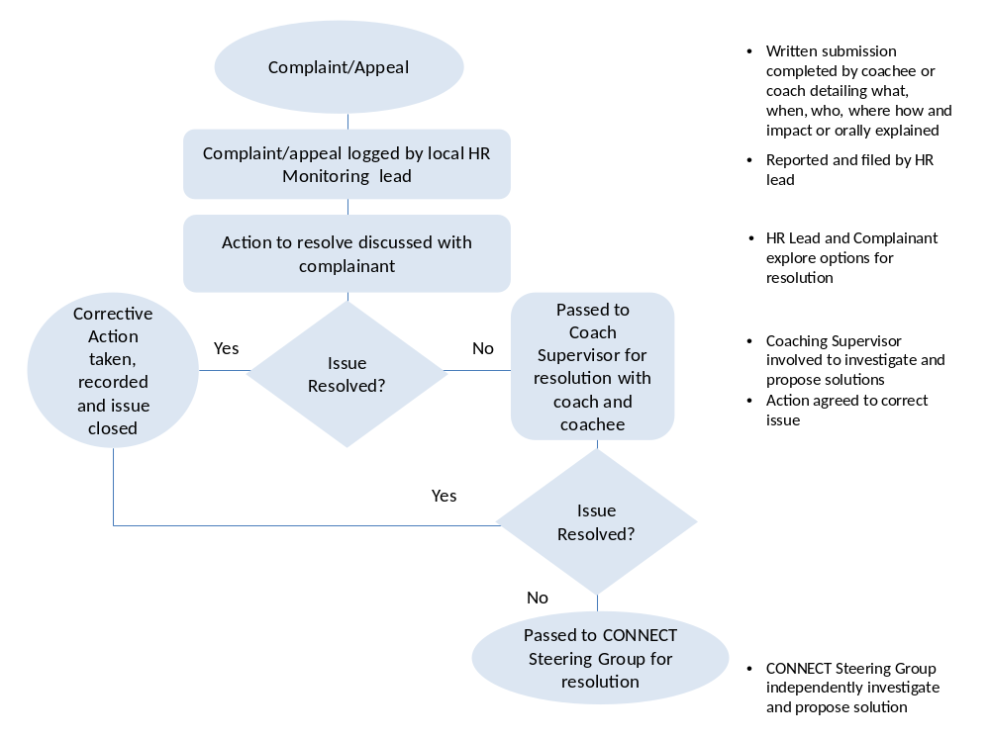

7 Integration of coaches with other credentials post 2012
Coaches who have been credentialed by awarding bodies other than ICF may be included in the Connect Coaching panel if they
- Met the minimum criteria(to be developed by the steering group)
- Attend a coach induction workshop (to be arranged by the coach mentors)

TEMPLATE ONE: REQUEST FOR COACHING

Name:
Job Role:
Organisation:
Telephone:
Mobile:
Email:
Address:
Reason for requesting a coach:  (Please select) | - Develop career direction and plan  - Leading service improvement or development initiatives,  - Facing a work based challenge  - Newly appointed to their role  - Personal development  - Understanding Personal Competencies
Sponsor’s supporting comments:
Sponsor’s Name
Telephone & Mobile:
Email:

TEMPLATE TWO: COACH PROFILE

Name:
Organisation:
Telephone:
Mobile:
Email:
Address:
Philosophy of coaching:
Up to 5 descriptive phrases / adjectives about you as a coach:
Coaching Experience including training and credentials:

TEMPLATE THREE: COACH AGREEMENT
Coach Agreement between:
COACHEE (print name):
and COACH (print name):
Specific Goals for Coaching:
Success outcomes/indicators:
Planned number of sessions:
Duration of each session:
Progress Review date:
Notes:
- Cancellation by email or telephone is permissible up to 24 hours prior to the appointment. If more than 2 consecutive sessions are rearranged by the either party the Coach or Coachee may withdraw from the Coaching Contract.
- Confidentiality: the Coach recognises that anything the Coachee shares with them is regarded as confidential. The Coach will not disclose or use Coachee information unless failure to disclose will be a breach of organisational policy or lead to / support a criminal act.
- All information will be kept in compliance with relevant data protection legislation in N.Ireland and the Republic of Ireland.
- All parties will complete relevant evaluation formats on the completion of coaching
- For the process to be successful both coach and coachee need to commit to developing an open, respectful and trusting relationship. All parties commit to honouring the conditions outlined above and to communicate honestly about any problems arising in doing so. Both the coach and coachee will seek to implement any actions agreed between them.
The Coachee and Coach have read and agreed to the above. (Please sign as indicated below).

COACHEE: |  |  |  | Date:
COACH: |  |  |  | Date:
LINE MANAGER/SPONSOR  (as appropriate) |  |  |  | Date:

TEMPLATE FOUR: COACH SESSION NOTES

COACHING SESSION
Client
Coach
Meeting No
Date

Topics discussed:

Key Points:

Next Actions:

Next Session:

Date:
Time:
Location:

TEMPLATE FIVE a): COACHING EVALUATION - COACHEE

Name of Coachee: _____________________________________

Coach Name:
Please evaluate your coaching sessions by circling a numerical rating for each of the following questions, adding any written comments you may have. This evaluation will be shared with your Coach and used to evaluate the impact of the Connect Coaching Service. Please circle your rating.
Strongly Agree |  |  | Strongly Disagree
5 | 4 | 3 |  | 2 | 1

1. The Coach created safety and trust

Comments:

2. The Coach developed a contract with me based
5 | 4 | 3 | 2 | 1

on my goals
Comments:

3. The coaching increased my awareness and insight about
5 | 4 | 3 | 2 | 1

the issues I brought to coaching.

Comments:

4. The Coach was professional and credible
5 | 4 | 3 | 2 | 1

Comments:
5 | 4 | 3 | 2 | 1

5. The Coach assisted me to examine my issues
from a different perspective.

Comments:

5. The Coach helped me plan actions to achieve my goals
5 | 4 | 3 | 2 | 1

Comments:

6. Overall, the sessions with the Coach were useful.
5 | 4 | 3 | 2 | 1

TEMPLATE FIVE b): COACHING EVALUATION - SPONSOR

Connect Coaching Service: Sponsor Evaluation

Your name: ________________________________________

Contact Number: ______________________________________

Your member of staff’s name: _______________________________________

Today’s date: ________________________________

You supported this individual’s request to receive coaching to assist them in the development of their role.

Based on the reasons for the request, please rate how you perceive the effectiveness of the coaching support provided to your member of staff on a scale of 0 – 10,

where 0 = no impact and 10 = excellent outcome

Please circle the appropriate rating

0 1 2 3 4 5 6 7 8 9 10

Please give a reason for your score in the box below.

Thank you for your help.
Your feedback will be used to evaluate and improve the Connect Coaching Service.

TEMPLATE FIVE C): COACHING EVALUATION - COACH

Connect Coaching Service: Coach Evaluation

Your name: ________________________________________

Contact Number: ______________________________________

Your Coachee’s name: _______________________________________

Today’s date: ________________________________

You provided coaching to assist this person in the development of their role.

Please rate how you perceive the effectiveness of the coaching support you provided in addressing the goals and outcomes that were agreed on a scale of 0 – 10,

where 0 = no impact and 10 = excellent outcome

Please circle the appropriate rating

0 1 2 3 4 5 6 7 8 9 10

Please give a reason for your score in the box below.

Thank you for your help.
Your feedback will be used to evaluate and improve the Connect Coaching Service.

APPENDIX ONE: CODE OF ETHICS
The ICF Code of Ethics

Part One: Definition of Coaching
- Coaching: Coaching is partnering with clients in a thought-provoking and creative process that inspires them to maximize their personal and professional potential.
- A professional coaching relationship: A professional coaching relationship exists when coaching includes a business agreement or contract that defines the responsibilities of each party.
- An ICF Professional Coach: An ICF Professional Coach also agrees to practice the ICF Professional Core Competencies and pledges accountability to the ICF Code of Ethics.
In order to clarify roles in the coaching relationship, it is often necessary to distinguish between the client and the sponsor. In most cases, the client and sponsor are the same person and therefore jointly referred to as the client. For purposes of identification, however, the International Coach Federation defines these roles as follows:
- Client: The "client" is the person(s) being coached.
- Sponsor: The "sponsor" is the entity (including its representatives) paying for and/or arranging for coaching services to be provided.
In all cases, coaching engagement contracts or agreements should clearly establish the rights, roles, and responsibilities for both the client and sponsor if they are not the same persons.
Part Two: The ICF Standards of Ethical Conduct
Preamble: ICF Professional Coaches aspire to conduct themselves in a manner that reflects positively upon the coaching profession; are respectful of different approaches to coaching; and recognize that they are also bound by applicable laws and regulations.
Section 1: Professional Conduct At Large
As a coach:
- I will not knowingly make any public statement that is untrue or misleading about what I offer as a coach, or make false claims in any written documents relating to the coaching profession or my credentials or the ICF.
- I will accurately identify my coaching qualifications, expertise, experience, certifications and ICF Credentials.
- I will recognize and honor the efforts and contributions of others and not misrepresent them as my own. I understand that violating this standard may leave me subject to legal remedy by a third party.
- I will, at all times, strive to recognize personal issues that may impair, conflict, or interfere with my coaching performance or my professional coaching relationships. Whenever the facts and circumstances necessitate, I will promptly seek professional assistance and determine the action to be taken, including whether it is appropriate to suspend or terminate my coaching relationship(s).
- I will conduct myself in accordance with the ICF Code of Ethics in all coach training, coach mentoring, and coach supervisory activities.
- I will conduct and report research with competence, honesty, and within recognized scientific standards and applicable subject guidelines. My research will be carried out with the necessary consent and approval of those involved, and with an approach that will protect participants from any potential harm. All research efforts will be performed in a manner that complies with all the applicable laws of the country in which the research is conducted.
- I will maintain, store, and dispose of any records created during my coaching business in a manner that promotes confidentiality, security, and privacy, and complies with any applicable laws and agreements.
- I will use ICF member contact information (e-mail addresses, telephone numbers, etc.) only in the manner and to the extent authorized by the ICF.

Section 2: Conflicts of Interest
As a coach:
- I will seek to avoid conflicts of interest and potential conflicts of interest and openly disclose any such conflicts. I will offer to remove myself when such a conflict arises.
- I will disclose to my client and his or her sponsor all anticipated compensation from third parties that I may pay or receive for referrals of that client.
- I will only barter for services, goods or other non-monetary remuneration when it will not impair the coaching relationship.
- I will not knowingly take any personal, professional, or monetary advantage or benefit of the coach-client relationship, except by a form of compensation as agreed in the agreement or contract.

Section 3: Professional Conduct with Clients
As a coach:
- I will not knowingly mislead or make false claims about what my client or sponsor will receive from the coaching process or from me as the coach.
- I will not give my prospective clients or sponsors information or advice I know or believe to be misleading or false.
- I will have clear agreements or contracts with my clients and sponsor(s). I will honor all agreements or contracts made in the context of professional coaching relationships.
- I will carefully explain and strive to ensure that, prior to or at the initial meeting, my coaching client and sponsor(s) understand the nature of coaching, the nature and limits of confidentiality, financial arrangements, and any other terms of the coaching agreement or contract.
- I will be responsible for setting clear, appropriate, and culturally sensitive boundaries that govern any physical contact I may have with my clients or sponsors.
- I will not become sexually intimate with any of my current clients or sponsors.
- I will respect the client's right to terminate the coaching relationship at any point during the process, subject to the provisions of the agreement or contract. I will be alert to indications that the client is no longer benefiting from our coaching relationship.
- I will encourage the client or sponsor to make a change if I believe the client or sponsor would be better served by another coach or by another resource.
- I will suggest my client seek the services of other professionals when deemed necessary or appropriate.

Section 4: Confidentiality/Privacy
As a coach:
- I will maintain the strictest levels of confidentiality with all client and sponsor information. I will have a clear agreement or contract before releasing information to another person, unless required by law.
- I will have a clear agreement upon how coaching information will be exchanged among coach, client, and sponsor.
- When acting as a trainer of student coaches, I will clarify confidentiality policies with the students.
- I will have associated coaches and other persons whom I manage in service of my clients and their sponsors in a paid or volunteer capacity make clear agreements or contracts to adhere to the ICF Code of Ethics Part 2, Section 4: Confidentiality/Privacy standards and the entire ICF Code of Ethics to the extent applicable.
Part Three: The ICF Pledge of Ethics
As an ICF Professional Coach, I acknowledge and agree to honor my ethical and legal obligations to my coaching clients and sponsors, colleagues, and to the public at large. I pledge to comply with the ICF Code of Ethics, and to practice these standards with those whom I coach.
If I breach this Pledge of Ethics or any part of the ICF Code of Ethics, I agree that the ICF in its sole discretion may hold me accountable for so doing. I further agree that my accountability to the ICF for any breach may include sanctions, such as loss of my ICF membership and/or my ICF Credentials.
Approved by the Ethics and Standards Committee on October 30, 2008.
Approved by the ICF Board of Directors on December 18, 2008.

(Reproduced from ICF website: www.coachfederation.org)

Learning and Development Survey, CIPD , 2009; Coaching and mentoring: what they are and how to make the most of them, Jane Renton London: Economist in association with Profile Books, 2009

